A 1st Century Funerary Enclosure at Barnwood, Gloucestershire
Cotswold Archaeology has just completed a full report on the findings from a site excavated in 2014 at Barnwood, ahead of redevelopment, funded by Barnwood Construction Ltd. The excavations produced evidence for quarrying associated with the initial construction of Roman Ermin Street in the mid 1st-century AD, along with a funerary enclosure containing the remains of a cremated individual, possibly an adult male, perhaps a soldier or veteran of the Roman army. Amongst the many finds recovered during the excavation is an internationally important assemblage of samian pottery.
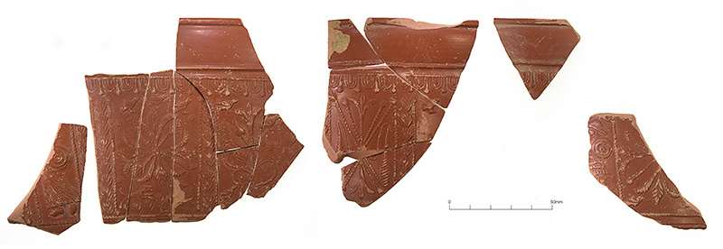Sherds from a decorated samian vessel from one of the quarry pits 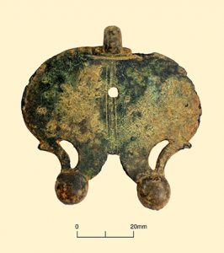A Roman military harness pendant recovered from one of the quarry pits
The site is located immediately to the north of Barnwood Road, which follows the alignment of Roman Ermin Street. This road ran from the early Roman legionary fortresses at Kingsholm and Gloucester (later the colonia of Glevum) south-eastwards to Cirencester (Roman Corinium). The earliest features recorded were a series of roadside quarry pits, probably dug to extract gravel used in the construction of the road. These pits were dated by samian pottery to between AD 40 and 70, indicating that Ermin Street was constructed as a metalled road within three decades of the Roman Conquest of AD 43. One of these pits contained a remarkable assemblage of finds, including hundreds of sherds of decorated samian, amphorae, vessel glass and metal objects. These include military harness fittings and a possible situla or ‘camp kettle’. Notably, the samian pottery is unused, as many of the base sherds retain the grits used to prevent vessels from fusing together in the kiln. This suggests that the assemblage is dominated by discarded stock, rather than being evidence for domestic occupation. Potters’ stamps on the samian provide a Neronian date range for the deposit, probably during the AD 60s.
After the construction of Ermin Street, a series of ditches with a central alignment of postholes was established, running at right-angles to the road. These were perhaps plot boundaries for a market garden. These features were within a large rectangular ditched enclosure, although it is somewhat unclear whether this enclosure was contemporary with the plot boundaries or slightly later. The garden plots were short-lived, as in the south-east corner of the large enclosure they were cut by a small (approximately 10m x 10m) square ditched enclosure; this contained a series of postholes indicating a square internal timber-built structure. Within the centre of this structure there was a number of pits, one of which contained a lead urn (an ossuarium) that held the cremated human remains of a possible adult male aged between 36 and 45. Another pit contained nails and hobnails, along with the remains of burnt broad beans and peas, perhaps part of a ritual food offering associated with funerary activity. The burial rite and use of a lead ossuarium strongly suggest that the individual had military connections and was perhaps a soldier or veteran of the Roman army.
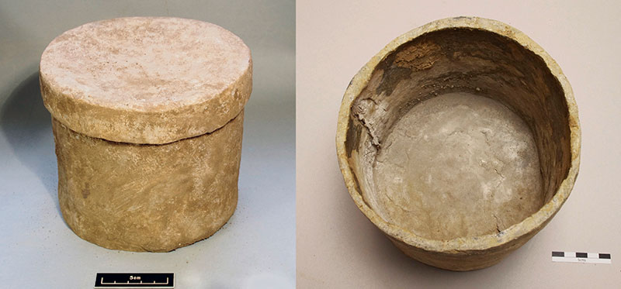lead urn (ossuarium) which contained the cremated remains of a possible Roman soldier
While precise dating evidence for the cremation burial was scarce, an unstratified partially melted glass vessel, of a type commonly used as pyre goods during the 1st-century AD, is likely to relate to the funerary activity.
Subsequent activity at the site included a probable drainage ditch following the alignment of Ermin Street, which had been dug through the quarry pits in the late 1st or 2nd-century; the creation of probable roadside plots during the medieval period; and further quarrying during the medieval and post-medieval periods.
Together, the Roman-period evidence from Barnwood is highly indicative of a Roman military presence, yet the site is located approximately 3km away from both the legionary fortress at Kingsholm and its slightly later replacement at Gloucester. This raises the possibility that the activity was associated with an unknown military base in the Barnwood area, perhaps an auxiliary fort. If this were the case, could the unused samian stock and other finds deposited in the quarry pits be associated with clearance during the abandonment of such a fort, perhaps deliberately broken to prevent reuse or resale? There are, of course, multiple other potential explanations; maybe the group represents stock damaged in transit along Ermin Street and disposed of in a convenient open quarry pit, along with other waste from a nearby military establishment? Or perhaps the finds relate to a roadside funerary ritual involving the placement of broken up pottery in pits near the funerary enclosure? We can never be certain of the true reason the material was deposited as it was, yet the construction of various interpretative possibilities represents one of the joys of doing archaeology.
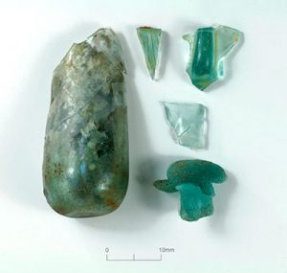Roman vessel glass from one of the quarry pits 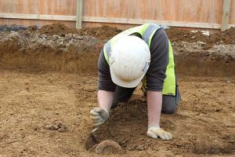Part of a Roman amphora being excavated from one of the quarry pits 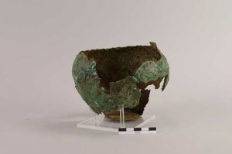The copper-alloy ‘camp kettle’ after conservation

